**TOPICS: Allowed Time:** 90 Minutes

Join tables, Sequence of commands and syntax, Concatenate

Drop table, Cascade deletion, Arithmetic operations, Insert

Update , Delete , Create, Alter

**INSTRUCTIONS: Total Marks:** 35

1. Gossips are not allowed.
2. Teacher assistants are for your help, so be nice with them. Respect them as they are teaching you. Raise your hands if you have some problem and need help from TA. Avoid calling them by raising your voice and disturbing the environment of Lab.
3. TA may deduct your marks for any kind of ill-discipline or misconduct from your side.
4. Evaluation will be considered final and you cannot debate for the marks. So, focus on performing the tasks when the time is given to you.
5. Paste the query as well as result table screenshot as a result of each task

**Task 01: _________________________ ___________ (10 Marks)**

Create a database named **STUDENTCOURSEDB** according to this schema

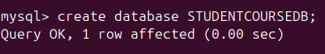

|  |  |  |
| --- | --- | --- |
| Table Name: **Student** | | |
| **Col Name** | **Data Type** | **constraints** |
| StudentID | CHAR(5) | Primary Key |
| FirstName | VARCHAR2(20) | Not Null |
| LastName | VARCHAR2(30) | Not Null |

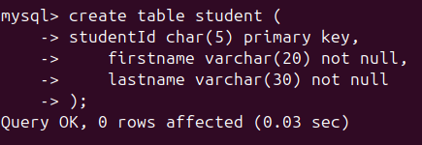

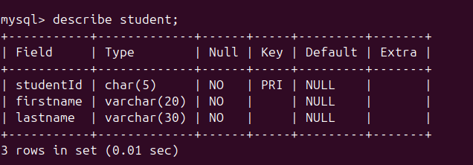

|  |  |  |
| --- | --- | --- |
| Table Name: **Class** | | |
| **Col Name** | **Data Type** | **constraints** |
| Class_Code | CHAR(5) | Primary Key,Not Null |
| Course_Code | Char(5) | Not Null |
| Class_Section | Int | Not Null |
| Class_Room | Varchar2(10) | Unique |
| Class_Teacher | Varchar2(10) | Not Null |

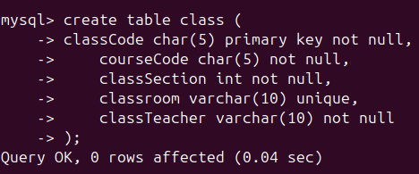

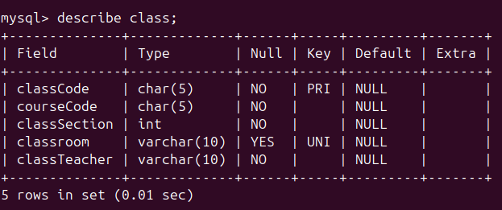

|  |  |  |
| --- | --- | --- |
| Table Name: **Enrollment** | | |
| **Col Name** | **Data Type** | **constraints** |
| Class_Code | CHAR(5) | Primary key,Not Null,references (Class) |
| StudentID | Char(5) | Primary key,Not Null,references (Student) |
| Enroll_Grade | Char(1) |  |

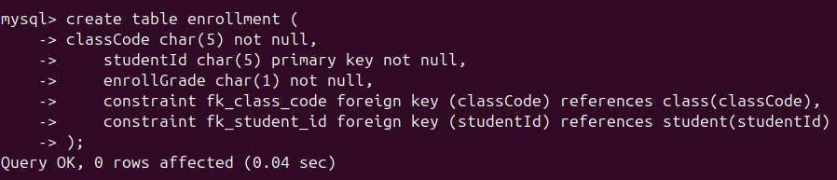

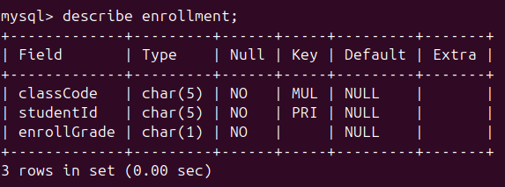

**Task 02: _________________________ ___________ (05 Marks)**

Insert records into the tables with the following data:

**STUDENT:**

|  |  |  |
| --- | --- | --- |
| **StudentID** | **FirstName** | **LastName** |
| S001 | John | Doe |
| S002 | Alice | Smith |
| S003 | Bob | Johnson |
| S004 | Mary | Brown |
| S005 | James | Williams |

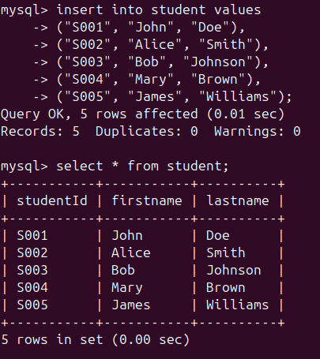

**CLASS:**

|  |  |  |  |  |
| --- | --- | --- | --- | --- |
| **Class_Code** | **Course_Code** | **Class_Section** | **Class_Room** | **Class_Teacher** |
| C101 | CS101 | 1 | 1 | Dr. White |
| C102 | CS102 | 2 | 2 | Dr. Green |
| C103 | CS103 | 3 | 3 | Dr. Black |

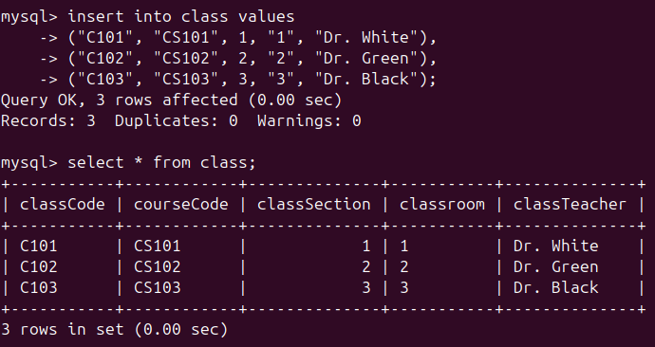

**ENROLLMENT:**

|  |  |  |
| --- | --- | --- |
| **Class_Code** | **Student_ID** | **Enroll_Grade** |
| C101 | S001 | A |
| C102 | S002 | B |
| C103 | S003 | C |
| C101 | S004 | A |

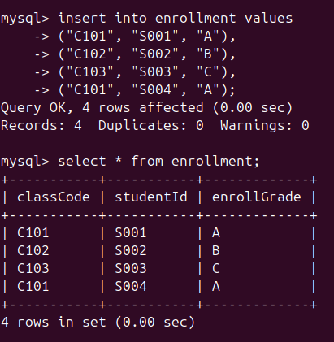

**Task 03: Update Statements____________ ___________ (04 Marks)**

**Note**: Before Doing This Tasks, Run this query: SET SQL_SAFE_UPDATES = 0;

Update data in the tables as follows:

1. Update the Class_Teacher for class C101 to "Dr. Smith", and also set Class_Section to 2.

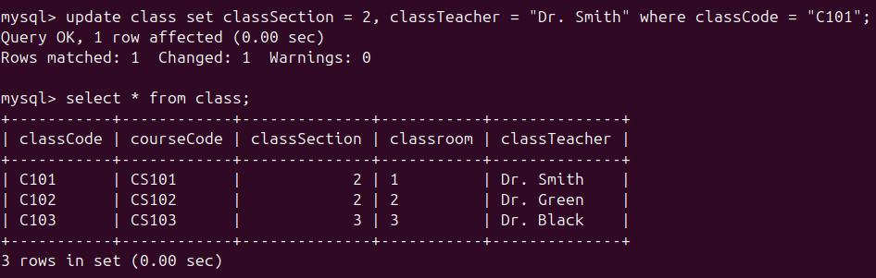

1. Change the LastName of a student where StudentID is 'S001' to "Johnson" and update FirstName to "Johnny".

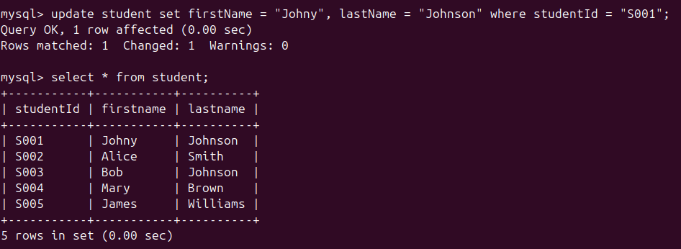

1. Update the LastName of students who have letter "B" in their first Name or Last Name and set their Last Name to "Green”.

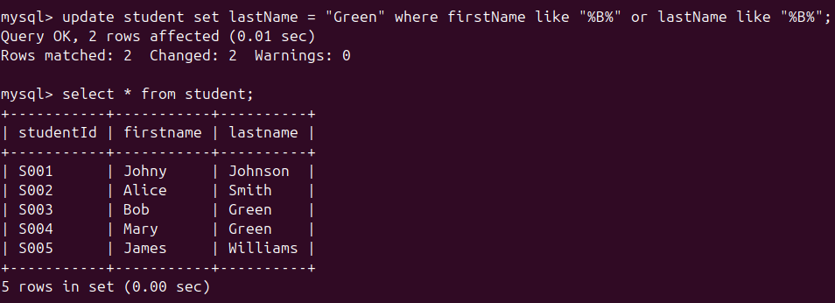

1. Update all classes to have Class_Section increased by 1 where the current Class_Section is less than 3.

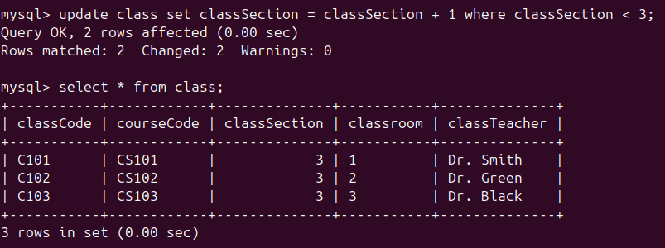

**Task 04: Alter Statements______________ ___________ (03 Marks)**

1. Add a new column named AdmissionDate to the Student table, and set the default value to the current date.

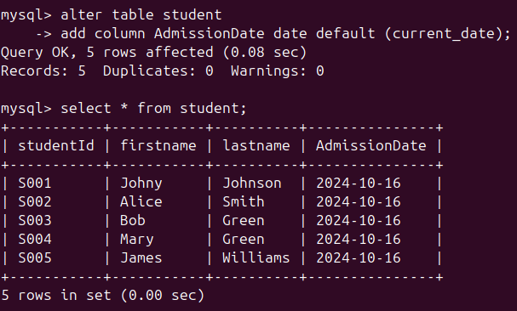

1. Change the data type of Class_Section in the Class table to TINYINT.

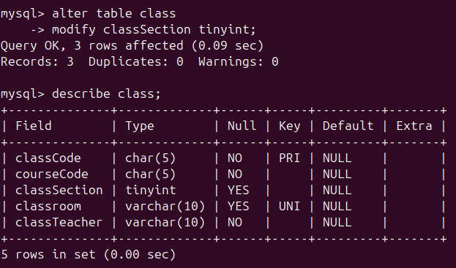

1. Add a unique constraint to the Course_Code column in the Class table.

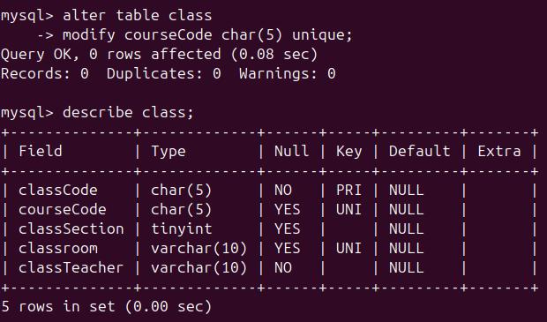

**Task 05: Simple Join Queries____________ ___________ (06 Marks)**

1. Retrieve the first name and last name of students along with their class codes.

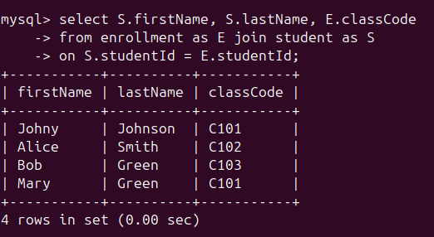

1. Display the first name, last name of students, class room, and class teacher.

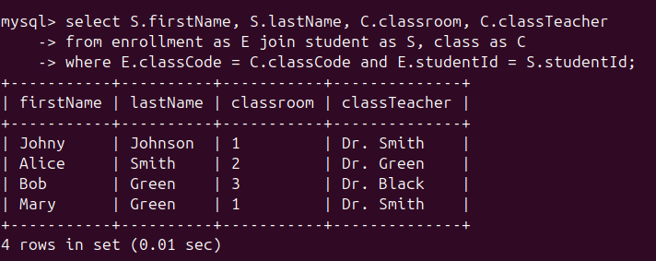

1. Show class code, class section, and student names for each class.

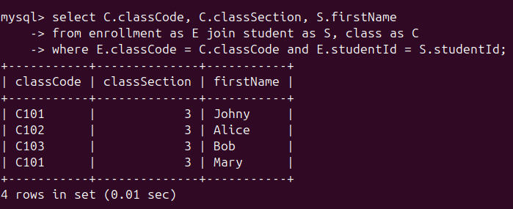

**Task 06: Cascade Deletion______________ ___________ (04 Marks)**

1. Set up cascading deletion so that if a record in the Class table is deleted, the corresponding records in the Enrollment table are also removed.

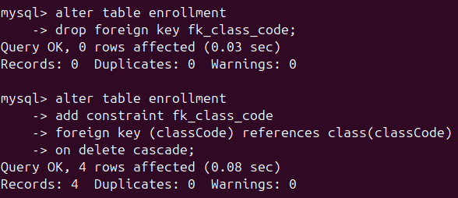

1. Test this by deleting the class record with Class_Code 'C101', and verify that all related enrollments are deleted.

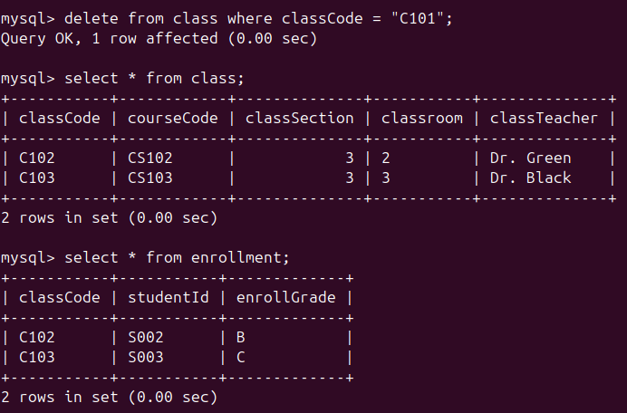

1. Enable cascading deletion from Student to Enrollment so that deleting a student also removes their enrollments.

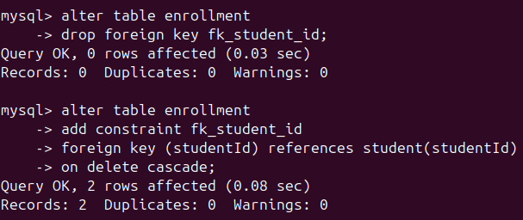

1. Delete a student with StudentID 'S002' and verify that the enrollment record for 'S002' is also removed.

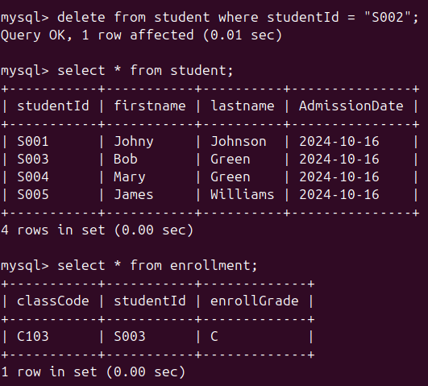

**Task 07: Delete Operations_____________ ___________ (02 Marks)**

1. Delete all students from the Student table where LastName is either 'Smith' or 'Williams'.

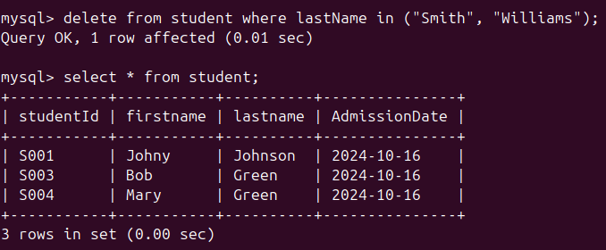

1. Delete all classes where the Class_Section is an odd number.

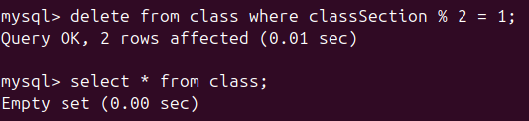

**Task 08: Drop Statements______________ ___________ (01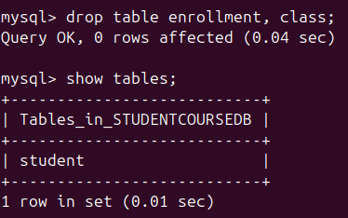 Marks)**

1. Drop the Enrollment table and the Class table.